# **Enuma Elish Dual Nature**

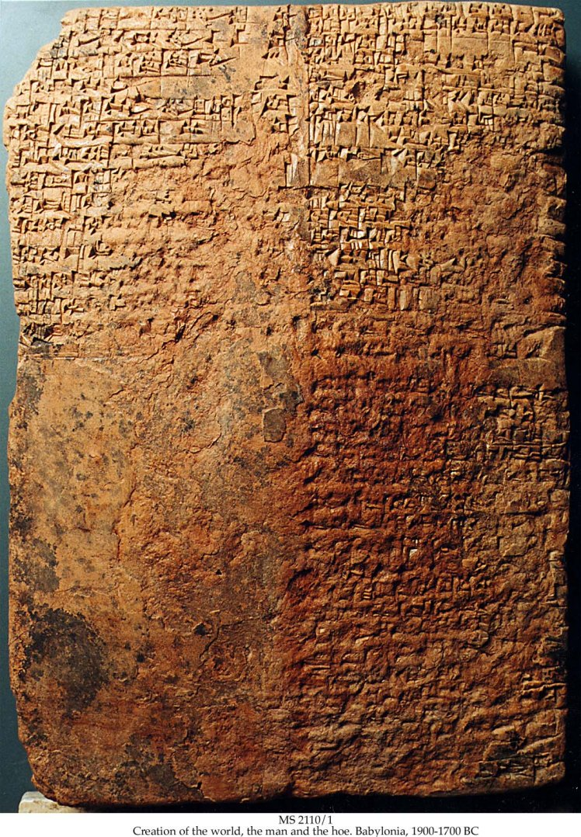

The *Enuma Elisha* (Enuma Elish, trans. Lambert) is an ancient myth that tells the story of where the Gods, the universe, and humans came from. It begins with the gods of saltwater and freshwater, Tiamat and Apsu, who give” birth” to younger gods. Tensions quickly rose, and Apsu, annoyed by the younger gods, planned to destroy them, but he was killed by Ea. Tiamat was furious and created an army of monsters led by Kingu. Marduk volunteered to fight, killed Tiamat, and became king of the gods. He used her body to form the heavens and earth, then captured Kingu and made humans from his blood. In this story, humans were created by the king of all the gods from the blood of Kingu, the leader of demons. This could suggest a heavy symbolic weight on the nature of people as being both divine and wonderful, but yet prone as well to evil from their dangerous origins. In the *Enuma Elisha*, mankind’s creation is both a divine act of order and a utilitarian solution shaped by the aftermath of cosmic conflict.

In the myth, the *Enuma Elish* (Enuma Elish, trans. Lambert), it alludes to how humans are both divine and have great potential, and how humans are born from the blood of the leader of a demon army, making them unpredictable and prone to evil and slothfulness. This is shown very evidently in daily life. People have great potential and can accomplish many amazing things, from building skyscrapers, to inventing the internet to creating great and beautiful works of art. However, humans are also capable of great waste and evil, five minutes watching the news will show you this—all the trash, waste of potential, evil, and sadness that humans have made. There is a great deal of potential in the human species, but it has to be drawn out purposefully and deliberately, otherwise our nature from Kingu will come out and create chaos. It is a constant struggle between our higher nature and our darker impulses, a battle that plays out in both our smaller daily choices and in larger historical events. Even with all our societal advancements, we are still often haunted by our origins, too often just one step away from chaos taking over.

In the story, Marduk—the hero representing divinity—rises to power not through peace, but by defeating chaos and establishing control; he shapes the world from Tiamat’s corpse. This suggests that the best way to embrace the side of myself that is divine and good is not simply to look only to good things, but to recognize that there is evil in the world and in myself, and to face and overcome it. In my life, I have seen a lot of chaos and uncertainty, and at different times I have ignored it, embraced it, or fought against it. Often, it feels easier to look away or give in, but that only makes the chaos stronger. It is only by actively deciding that I will fight against it and choose a better, higher way that I have found greater peace and joy, or a more divine way of life. I have learned that it’s not enough to just avoid doing bad things. I have to be actively seeking good, or I’ll slip into “the ways of Kingu.”

Lambert, W. G., translator. *Enuma Elish: The Babylonian Epic of Creation*. Oxford University Press, 2013.